Covid 19
With the uncertainty of the new Covid variant, we are already putting procedures in place should we be mandated to work from home again.
We have returned to a locked office door policy, and ask that should you wish to visit us, you call ahead to make an appointment.
Masks should be worn, and hand sanitiser is available upon entry. This is for the safety of all staff, family members and visitors.

Bank Details
On 14th September 2021 our bank details changed. Please can you ensure your rent is paid using the details below:
Lloyds
RFM (Rent from Me) T/A Elwy Sort: 30-65-64
Account: 18798168

A Great Big Thanks!
Festive Opening Hours
Thursday 23rd December
9am – 2pm

Friday 24th December CLOSED

Saturday 25th December – Tuesday 28th December CLOSED

Wednesday 29th December 10am – 2pm

Thursday 30th December 10am – 2pm

Friday 31st December - Monday 3rd January 2022
CLOSED

Tuesday 4th January 2022 Normal Opening Hours

Rent Payments should be paid as normal during the festive period.
Debit card payments can be taken only during office opening hours.

As the year draws to a close, we want to take this opportunity to thank you for your continued support throughout the year.

We’ve come through a year that was filled with challenges, victories and heart-breaking losses for many of us.

Many of you will be aware that Ray retired from the business and we have now taken over as the new owners and directors. The office has received a lovely new 'make-over' and we have updated the branding and social media channels!

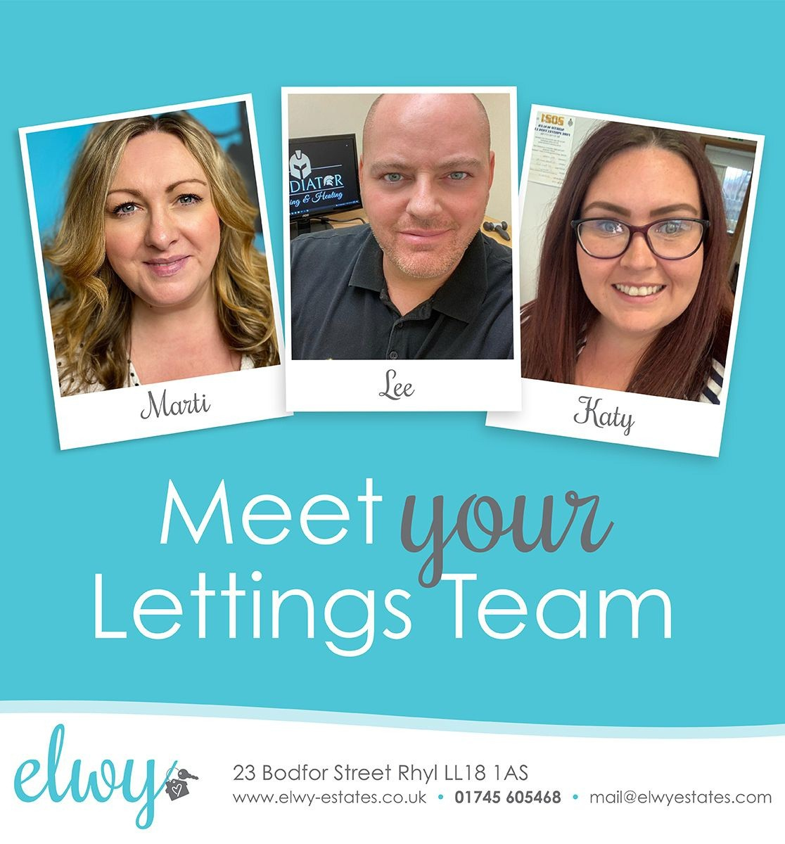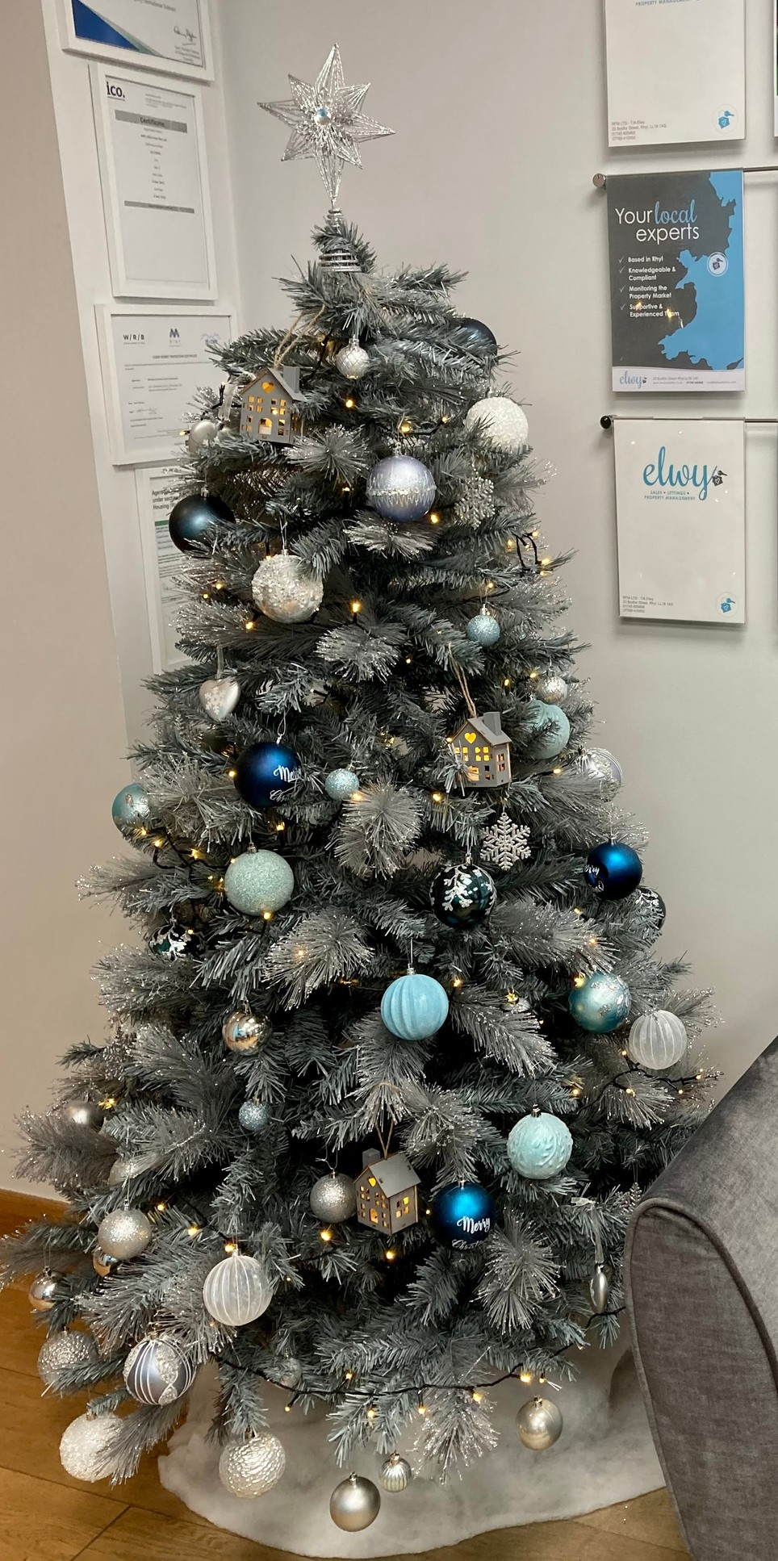We have made it easier for you to contact us by introducing an 'Elwy' business mobile, usually it will be me who replies, and we are finding that this is a faster and easier way for you to report an issue or just let us know something.

Katy joined the lettings team in June and we have received so much lovely feedback about her.

If you have time to leave a review about being a tenant of Elwy - please visit us on Facebook or Google Business!

We look forward to what 2022 holds - Wishing you a Merry Christmas & Happy New Year!

Contact Us:
t: 01745 605468
m: 07769 410950
e: mail@elwyestates.com

